No.1:

1. Using String literal :-

String s=”testing”;

1. Using new keyword:-

String sc=new String(“testing”);

No.2:

answer

* ,blu

No.3:

* The nextInt() is used to get the next random integer value from this random number generator’s sequence. The next integer is in range between 10 until 50.

No.4:

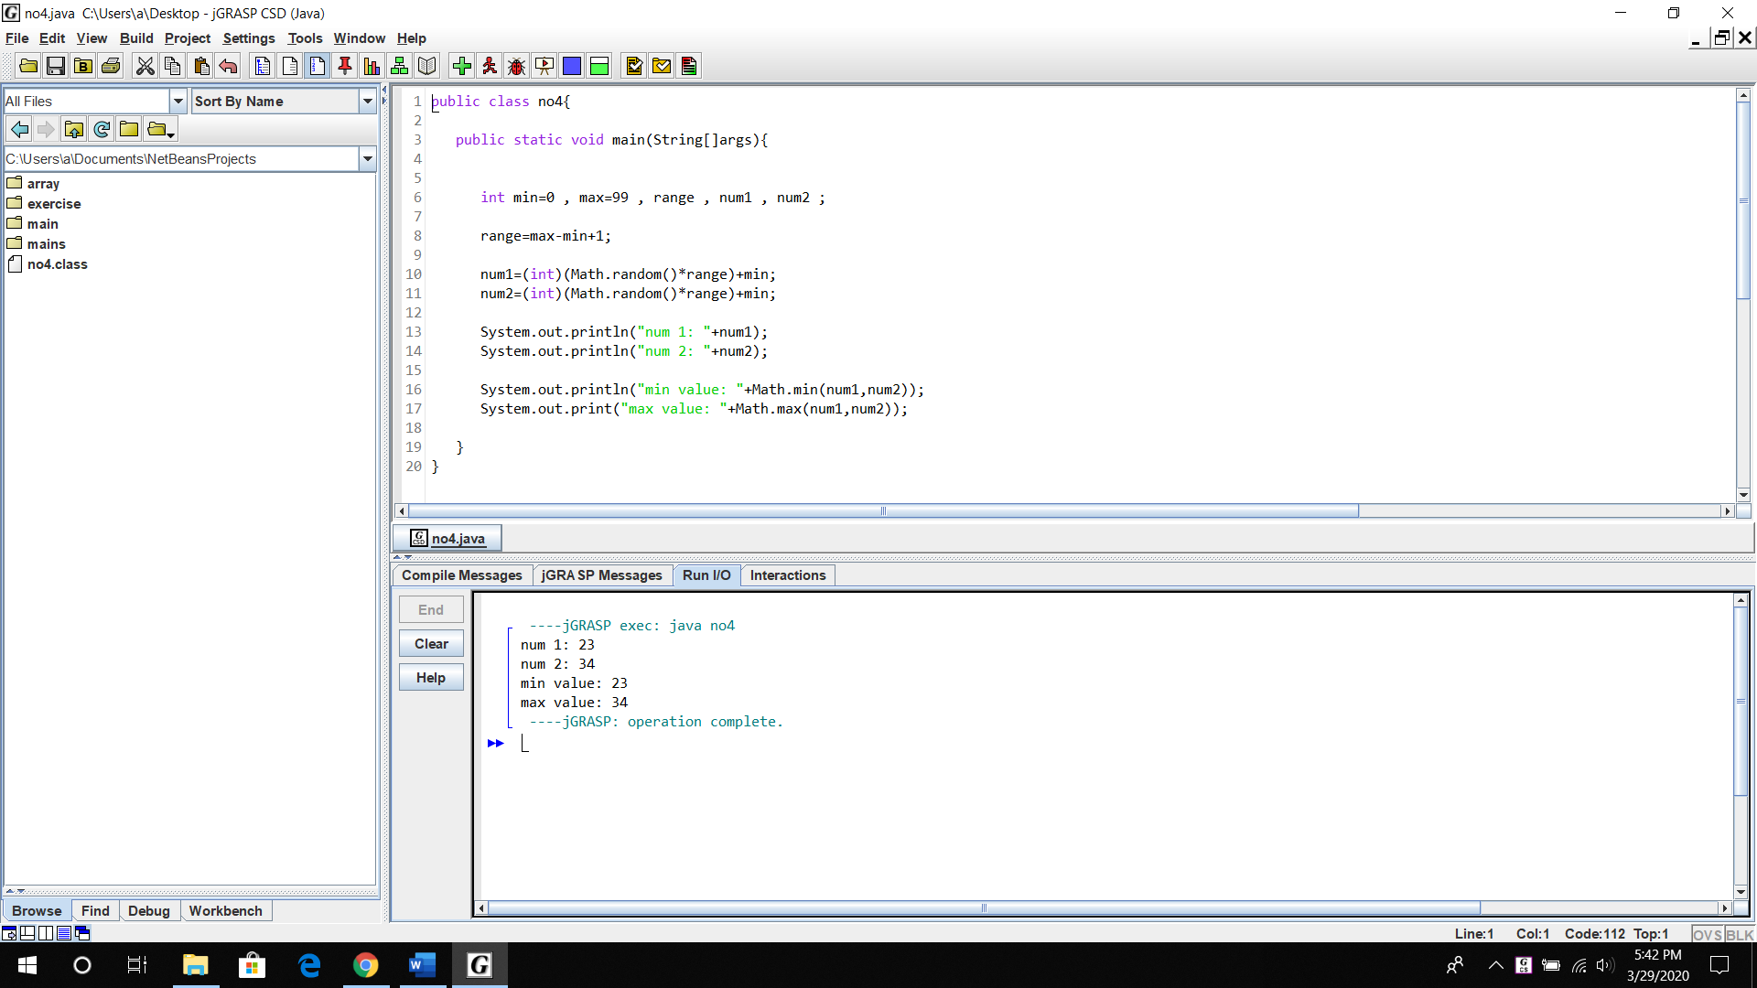

No.5:

* Answer

abcabc

The value is 3.0

No.6:

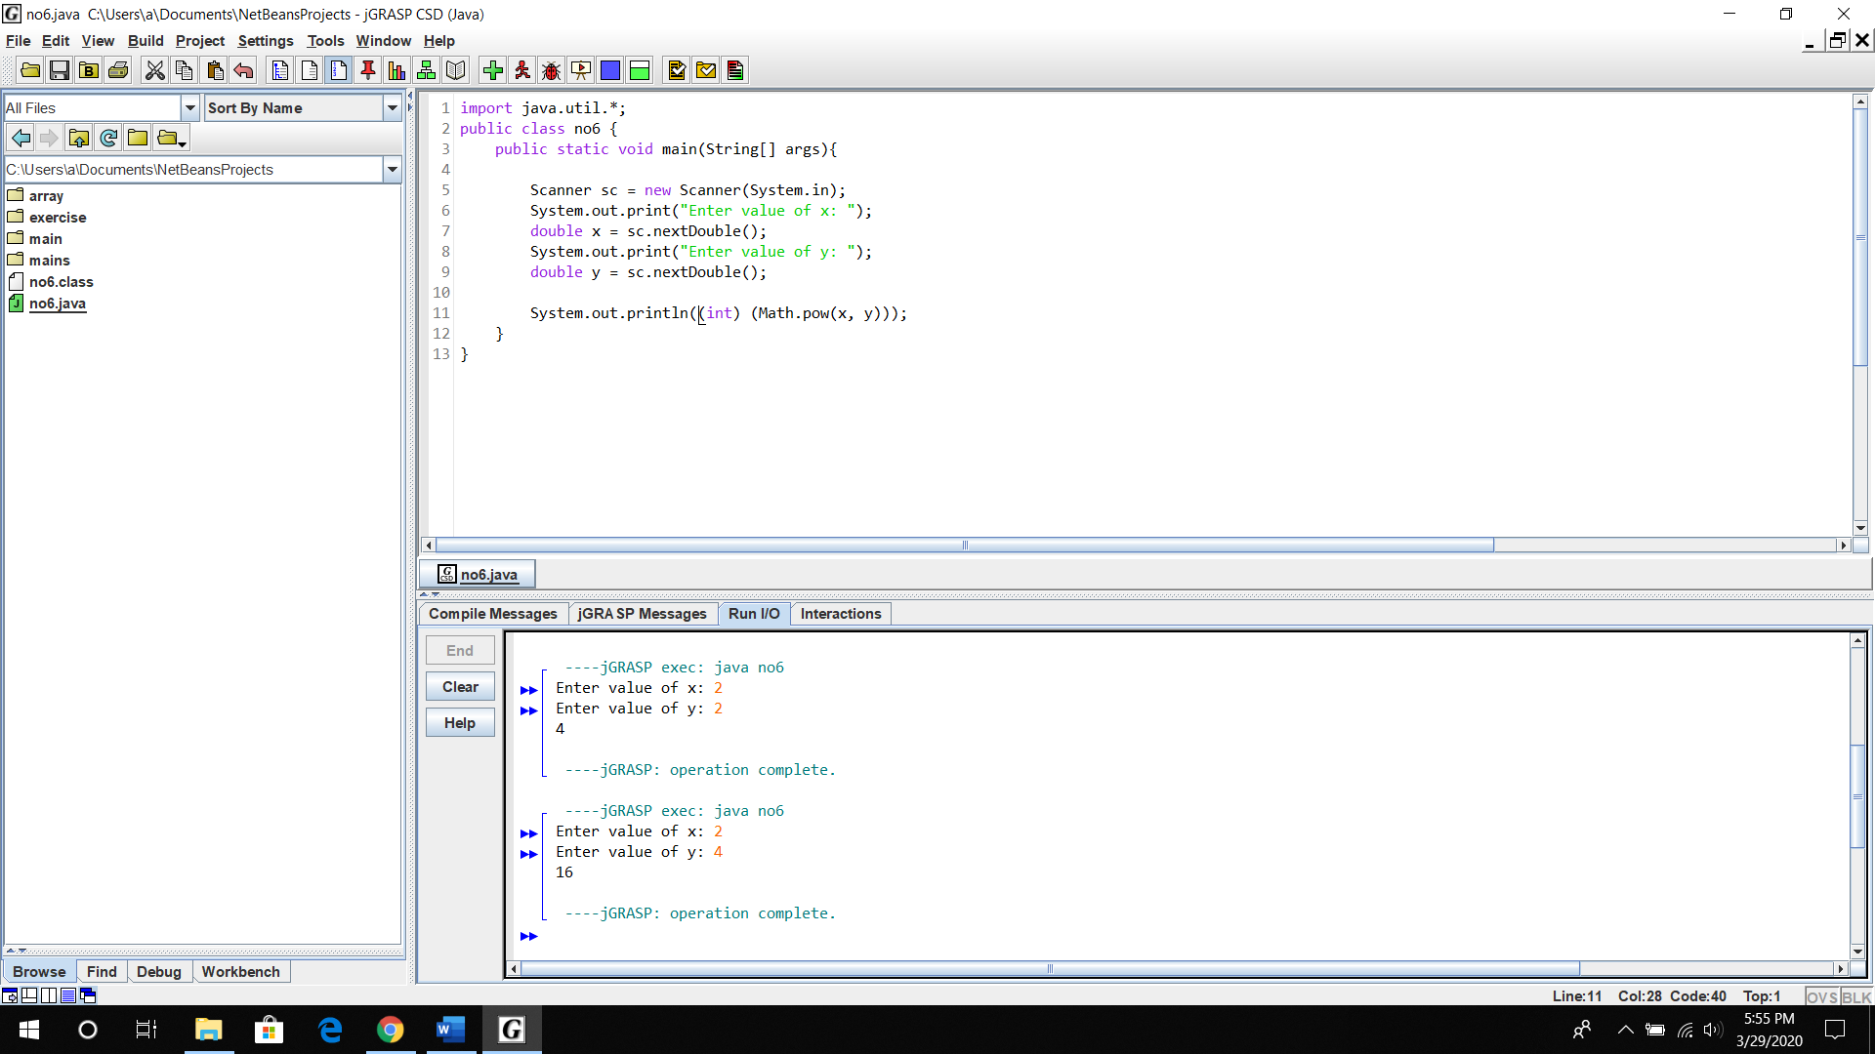

No.7:

